**NAME: JEEVITHA.S-192324020**

**DATA BASE MANAGEMENT SYSTEM FOR WEB APPLICATION(CSA0555)**

**ASSIGNMENT- 24 RAISE SALARY IN PROCEDURE**

create or replace procedure raise_sal(p_id in emplo.empid%TYPE,p_percent in number) is

begin

update emplo set netsal=netsal*(1+p_percent/100) where empid=p_id;

end;

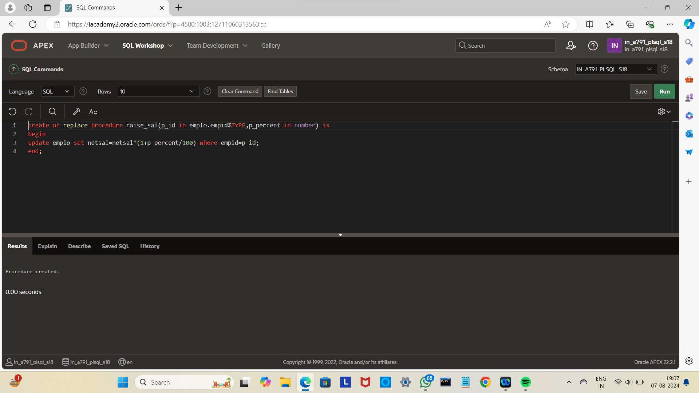

begin

raise_sal(103,10);

end;

/

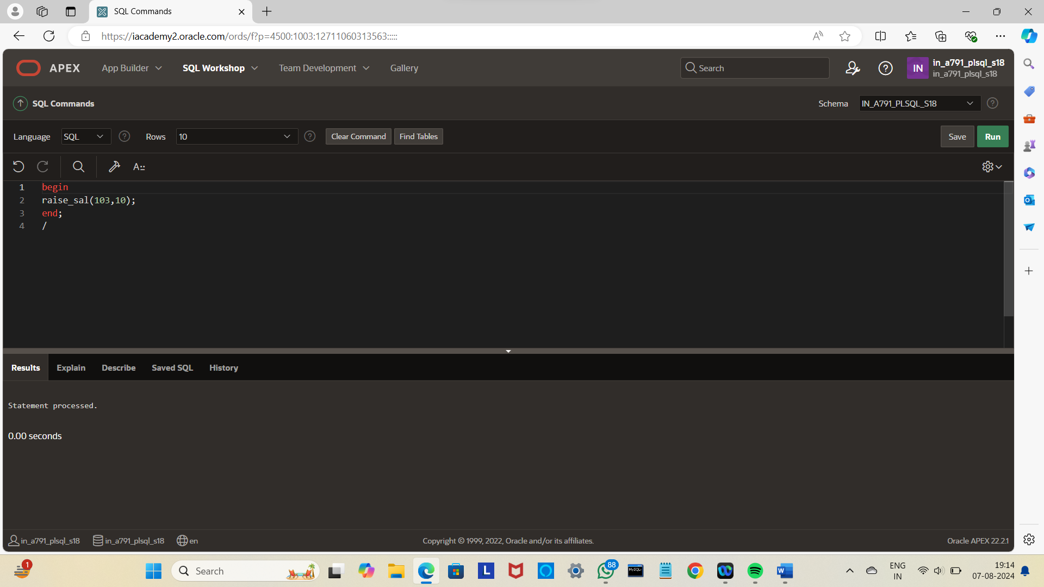

Select*from emplo;

